**ABSTRACT**

In this new era of technology the world is advancing towards new innovative technologies like robotics, automation and artificial intelligence. The rapid advancement in technology has brought in some form of automation in many industries today. Though lot of human activities are automated in the present competitive world. But a little attention is paid towards most basic and essential things like proper cleaning of utensils which can affect our hygiene and can be a reason for our health issues. Although people have tried to explore in this area and developed some automatic dishwashers but they are not efficient and consumes a lot of water. Some machines uses high velocity water only; hence there is a chance of partial cleansing and not removing tough strains in dishes. In order to overcome the above problems we have developed a special machine called ―”Automatic Dishwasher Machine” with rollers, brush and water jet introduced in this work. The main objective of our project is effective cleaning of utensils and to minimize the wastage of water so that it can be used in large scale areas like mega kitchens and hostel mess where cleaning is unhygienic and tones of water is wasted everyday.

**CONTENT**

**LIST OF TABLES**

**LIST OF FIGURES**

**1. INTRODUCTION…………………………………………………………..1**

**2. EXISTING DISHWAHER LAYOUT……………………………………..2**

**3. DRAWBACKS OF EXISTING AUTOMATIC DISH WASHING MACHINE…………………………………………………………………...…3**

**4. LITERATURE SURVEY…………………………………………………...5**

**5. WORKING OF PROPOSED DISHWASHER…………………………....6**

**6. CONSTRUCTION………………………………………………………….8**

**7. COMPONENTS USED……………………………………………………..9**

**8. ACTUAL PROJECT COMPONENTS…………………………………..15**

**9. DESIGN AND CALCULATIONS………………………………………..16**

**10. PROGRAMMING FOR WHOLE CYCLE…………………………………...20**

**11. ADVANTAGES ………………………………………………………………...27**

**12. LIMITATIONS………………………………………………………………….28**

**13. APPLICATIONS………………………………………………………………..28**

**14. PROJECT BUDGET……………………………………………………………29**

**15. CONCULSION AND FUTURE SCOPE ……………………………………...30**

**APPENDIX 1 ………………………………………………………………………..31**

**REFRENCES…………………………………………………………………….….32**

**LIST OF TABLES**

1. **THEORETICAL SPRAY COVERAGE AT VARIOUS DISTANCES IN INCHES (CM) FROM NOZZLE ORIFICE**

**LIST OF FIGURES**

1. **Fig.1-EXISTING DESIGN LAYOUT**
2. **Fig.2-CATIA Design (Alpha Design)**
3. **Fig.3-ACTUAL DESIGN LAYOUT**
4. **Fig.4-DISTANCE BETWEEN SHAFT CENTERS**
5. **Fig.5-MILD STEEL FRAME**
6. **Fig.6-SPRAY NOZZLES**
7. **Fig.7-ROLLER BEARING**
8. **Fig.8-CHAIN AND SPROKET**
9. **Fig.9-GENERAL LAYOUT**
10. **Fig.10-NOZZLE DESIGN (Spray angel and coverage)**
11. **Fig.11-NOZZLE PLACEMENT**
12. **Fig.12-PROCESS RATE & CYCLE TIME**
13. **Fig.13 – FINAL WORKING PROJECT**

**1. INTRODUCTION**

A dishwasher is a mechanical device for cleaning eating-utensils and dishes. Dishwashers can be found in private homes and hotels. Unlike manual dishwashing‘s, which depend largely on physical scrubbing to remove oiling, the mechanical dishwasher cleans by the brush and by spraying water, at the dishes. A mix of water and detergent is circulated by a pump. Water is pumped to one or more rotating sprays arms, which blast the dishes with the cleaning mixture. Once the wash is finished, the water is drained. After the rinse cycle finishes and the water is drained, and the dishes are left in the atmosphere for drying.

The function of the dishwasher is to provide the mechanical action necessary to distribute and direct the detergent solution and rinse waters over, under and around the dishes to loosen and remove soil. The dishwasher must also remove soil-laden waters from the machine after each phase of the cycle and provide for the drying of dishes after the cleaning process has been completed.

**2. EXISTING DISHWASHER LAYOUT**



**Fig.1 - EXISTING DESIGN LAYOUT**

Automatic dishwashers vary in the design of their washing systems. Some have a single water source, others may have several water sources. Water is distributed in dishwashers by spray arms or spray towers. The design of the spray arms or towers may differ in size, shape and placement in the dishwasher, or in the number, size and location of their water ports (holes through which water is forced). All of the washing systems do a good job, but those with fewer water sources require greater care in loading the dishes to prevent blocking the washing action to various parts of the machine, especially the corners. The total volume of water used in a complete cycle can vary from 6 - 10 gallons, depending on the number of washes and rinses included in that particular cycle.

**3. DRAWBACKS OF EXISTING AUTOMATIC DISH WASHING MACHINE**

Dish washing machines of automatic type are well known and generally operate more or less satisfactorily. The drawback exists, however that such machines are usually quite expensive and are quite bulky and that operating auxiliaries mounted under the bottom wall restricts the useful space inside the machine.

Furthermore such machines normally have rotating supply pipes which add to the expense and which require clear space for the operation thereof.

Now today, we have improved method of controlling a washing cycle having a tub, a lower spray arm and an upper spray arm disposed in the tub, a water circulating system including a pump for selectively supplying the spray arms with water, and a heater having a heating element in the tub. Although, by using this method we can reduce the wastage of water but still such kind of method cannot be used for large scale purposes, where we need to cleaning large number of plates at a fast rate.

For household purposes we have water wastage by implementing draining and drying cycles. In which, toward the end of the rinse and hold cycle when the water is draining, a second quantity of water is added to the machine resulting in a purging action which reduces the concentration of soil in the wash pump. During the normal wash cycle, if the dishwashing machine determines that the water is sufficiently dirty, a second drain is initiated to remove any dirty water that is present in the bottom of the pump after the first drain. During the dry cycle, the machine senses the temperature of the water and the presence of a rinse aid to select an appropriate dry cycle. The possible dry cycles include a delayed dry cycle and a pulsed dry cycle. But still such kind of cycle can’t be implemented for large scale cleaning of plates.

In design proposed by Pual B. Geiger, fill control for an automatic washer, the re-circulating pump output is monitored as the pump is operated during each fill cycle, and the fill is terminated just when the desired pump output is reached. The output is less than the pump maximum and results from continuous aspiration of water and air into the pump inlet, thus using only the minimum liquid necessary, and automatically reducing liquid consumption during subsequent fills as the washing operation progresses. The pump inlet faces downwardly at the bottom of the dishwasher tank to control surging. By implementing such design we may be able to reduce water wastage but rate of plates cleaned per minute will be less.

The purpose of our project is to eliminate the complex rotary spray heads, wherein the cycle can be made simple and adjustable to different circumstances.

The foregoing objective and advantages of our project will become more apparent upon reference to the following detailed specification as mentioned below.

**4. LITERATURE SURVEY**

Various cleaning procedures are reported in the literature. The simplest one involved rinsing brushing of dish using water which significantly removed a high level of bacteria (Miller et al., 1996). Interestingly, use of chemical cleaners did not statistically improve the performance. Similarly, Abrishami (1994) reported the use of an automatic dishwasher with only cold water to remove bacterial contamination from a dish. In this solution she also introduced the spraying arms. In that model, the rinse phase was also introduced; the introduction of electrical appliances in this modern life kitchen has determined the born of new era and the dishwasher manufactures have seen a speedy increase of the production volume for this appliance. In paper - an automatically controlled dishwashing machine written by ―Wesley C.Cox they conclude that in order to improve the Dishwashing process without human efforts and the removal of any bacteria which may remain by rising with clear water. The essential step in washing of eating utensils are the removal of all soil by washing of eating utensils are the removal of all soil by washing for the optimum length of time with water in which a suitable detergent has been added in proper concentration. In paper - field studies on two and three compartment sink manual dishwashing written by Morris. He observed that improper cleaned and sanitizes dishes constitute a health hazard.

Surveying the existing dishwashing machines in the market we observed many defects in the system such as wastage of water, requirement of man power, high installation cost, poor quality of cleaning etc. Hence, we decided to implement a dishwashing machine which will not only overcome these defects but also provide optimized cleaning. So for efficient cleaning of dishes we can use this system. In future by modifying this system we can clean the big utensils, glassware, etc.

**5. WORKING OF PROPOSED DISHWASHER**

Auto dishwashing machine is a kind of mechanical machine which can be widely used for cleaning eating-utensils and dishes in private homes and hotels to eliminate the job of hand washing. Especially have higher efficiencies than other types of manual dishwashing (which depend largely on physical scrubbing to remove soiling).

It consists of three stages:-

1. **Hot water spray**

First plate is fed to the system, vertically. In which two attachments on chain will hold the plate straight, in position and in this stage hot water is sprayed in the plate to remove the oil and few leftover food pieces. It will take 15 seconds for removing oil per plate. After most strains are removed, chain will move forward and take plate to the next stage.

1. **Detergent spray and cleaning by the brush**

In this stage, detergent is sprayed on plates in form of mist. Then, detergent covered plate comes in contact with brushes, which rotates continuously and cleans the plate. 15 seconds are spent on each plate.

1. **Fresh water cleaning**

In this stage fresh water is sprayed with of nozzles to remove foam, formed by detergent. It takes 15 seconds for cleaning with fresh water per plate.

After the rinse cycle finishes and the water is drained, and the dishes are left in the atmosphere for drying.

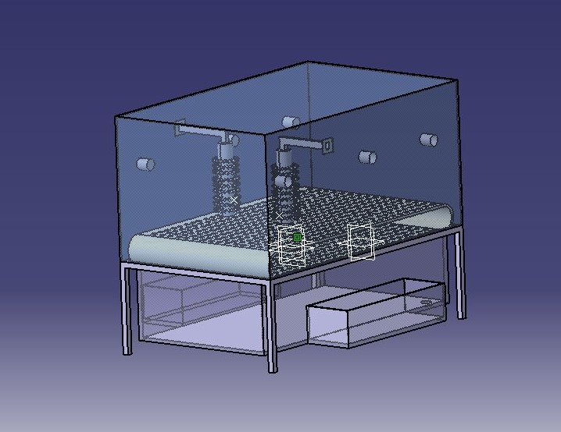

**Fig.2 - CATIA Design (Alpha Design)**

Initial design was consists of four stages:-

1. Hot water spray
2. Soap detergent spray
3. Cleaning  by brush with the help of nozzles
4. Fresh water cleaning.

After the rinse cycle finishes and the water is drained, and the dishes are left in the atmosphere for drying. First, the plate to be cleaned is fed into the system. Once the dish is inserted, the roller will pull the dish automatically and hot water will be sprayed on the plate to remove the oil and stains on the plate. Next, soapy water mixture is forced to pass through the spray arms which spray high pressure water to clean the incoming plate. The brushes in the form of rollers are used which rotates continuously and cleans the incoming plate. In the last stage fresh water cleans the dishes for few seconds and they are now ready for drying.

**6. CONSTRUCTION**

In this Automatic Dishwasher Machine, the shaft is fitted into the roller on either side. The sheet metal is drilled to the size equal to the diameter of shaft . With the aid of welding the bearing is placed in the sheet metal where the drilling has been done. The shaft is supported with the help of bearing to reduce friction and helps it spin very smoothly. Two gears are welded on each shaft at a certain distance. Cycle chain is mounted on these gears. The plate is held upright with the help of V-shaped notch made of mild steel. There is not very much contact area holding that load. Since the load is relatively small it can easily handle radial thrust. The pulley (a simple machine that has many complex uses) is fitted at the end of the shaft. The common user is to create motion transfer with the least amount of effort; it has a groove around its circumference. Here the drive element used is a DC motor. A pulley is also fixed in the shaft of the motor. The drive element of a pulley used in the system is belt that runs over the pulley inside the groove. The power to the drive is given through the adaptor from the main.

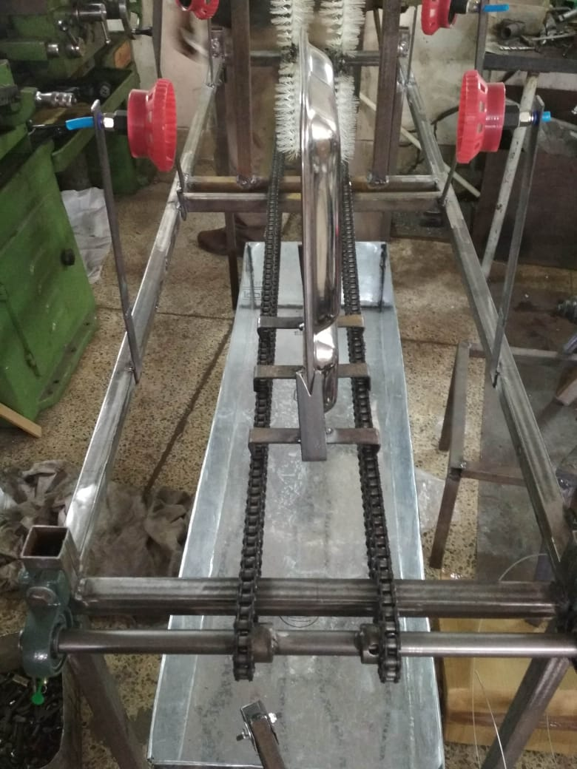

**Fig.3 - ACTUAL DESIGN LAYOUT**

**7. COMPONENTS USED**

**A. Roller with brush**

This is the main component of this machine. Roller Brushes are made as per the specification given by the customer. The overall diameter and length can be varied. The brush can be offered with or without shaft. Application areas are truly vast.

**B. Chain drive**

A mechanism in which power is transmitted by the movement of a continuous chain.

Types of Chains:

* Roller chain
* Detachable chain
* Pintle chain
* Silent chain
* Leaf chain
* Laminated metal chain

In our project we have used two parallel roller chains (cycle chain) to carry the plate in between them.

Designing of chain drive mechanism:

1. **Operating conditions**

When selecting roller chains, the following seven parameters should be taken into account:

a. Machine to be used

b. Diameter and rotary speed of high-speed shaft

c. Impact type

d. Diameter and rotary speed of low-speed shaft

e. Prime motor type

f. Inter-shaft distance

g. Power transmission (kW)

1. **Application coefficient**

Select the application coefficient from the application table which is appropriate for the machine to be driven and the prime motor type.

1. **Corrected power transmission (kW)**

Correct the power transmission (kW) using the application coefficient.

* Single chain - corrected power transmission (kW) = Power Transmission(kW) × Application Coefficient
* Multiple chain - Select the appropriate coefficient from the table multiple-chain power transmission coefficients.

**Corrected power transmission (kW) = (Power transmission (kW) × Application coefficient) / Multiple row coefficient**

1. **Chain and number of sprocket teeth**

Using or the power transmission efficiency table, select the chain and the number of small sprocket teeth that satisfy the rotary speed of the high-speed shaft and the corrected power transmission (kW). The chain pitch should be as small as possible, as long as the required power transmission efficiency is achieved. This should minimize noise and ensure smooth transmission of power. If a single chain does not provide the required power transmission efficiency, use multiple chains instead. If the installation space requires that the inter-shaft distance as well as the outer diameter of sprocket be minimized, use small-pitch multiple chains. There should be a minimum wrap angle of 120˚ between the small sprocket and the chain.

1. **Number of large sprocket teeth**

**Number of large sprocket teeth = Number of small sprocket teeth × Speed ratio**

Once the number of small sprocket teeth is determined, multiplying this by the speed ratio provides the number of large sprocket teeth. Generally, the appropriate number of small sprocket teeth is 17 or greater, or 21 or greater for high-speed operation, or 12 or greater for low speed operation. The number of large sprocket teeth should be 120 or less. Select the sprocket with as great a number of teeth as possible for a speed ratio of 1:1 or 2:1. The speed ratio should normally be 1:7 and ideally 1:5.

**6. Shaft diameter**

Ensure that the small sprocket selected as above is compatible with the diameter of the existing shaft on which it is to be installed. Refer to the specification table on this page. When the shaft diameter is too large for the bore in the sprocket, select another sprocket with a greater number of teeth or a larger chain.

1. **Inter-shaft distance between sprockets**

The distance between the shafts can be reduced as long as the sprockets do not interfere with each other and the wrap angle between the small sprocket and the chain is 120˚ or more. Generally, the inter-shaft distance should preferably be 30~50 times the pitch of the chain used. Under pulsating load conditions, decrease the distance to 20 times the chain pitch or less.

1. **Chain length and distance between shaft centre**

Once the chain is selected, the number of teeth on both sprockets, and the inter-shaft distance are available, then determine the number of chain links as follows.

Lp : Chain length expressed in number of links

N1 : Number of large sprocket teeth

N2 : Number of small sprocket teeth

Cp : Distance between shaft centre expressed in number of links

( π ≈ 3.14)

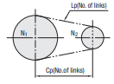

**Fig.4 - DISTANCE BETWEEN SHAFT CENTERS**

1. Calculating the chain length (when the number of sprocket teeth N1 and N2 and the distance between shaft centers Cp are available)
2. Calculating the distance between shaft centers when the number of sprocket teeth N1,and N2 as the chain length Lp are available.

**C. Pulley**

A pulley is a wheel on a shaft that is designed to support movement and change of direction of a taut cable or belt along its circumference. Pulleys are used in a variety of ways to lift loads, apply forces, and to transmit power.

**D. Shaft**

Several small bits of shafts are used. Mild steel of about 20mm diameter are polished well using abrasive clothes. Eight shafts are length of 100mm is used and they are turned and stepped by holding it in a centre lathe. The steel shaft of one end is connected with the roller and another end is fitted with pulley. It helps to rotate the roller brush easily and smoothly.

**E. Sheet metal**

Sheet metal is metal formed by an industrial process into thin, flat pieces. It is one of the fundamental forms used in metalworking and it can be cut and bent into a variety of shapes. Countless everyday objects are constructed with sheet metal.

We have used the GI sheet to build the sump tank to collect the waste water after the cleaning operation of plate. The tank needs to be emptied after definite intervals.

**F. Bearing and its function**

A ball bearing is a type of rolling element bearing that uses balls to maintain the separation between the bearing races. The purpose of a ball bearing is to reduce rotational friction and support radial and axial loads. It achieves this by using at least two races to contain the balls and transmit the loads through the balls.

In most applications, one race is stationary and the other is attached to the rotating assembly e.g., a hub or a shaft. As one of the bearing races rotates it causes the balls to rotate as well. Because the balls are rolling, they have a much lower coefficient of friction than if two flat surfaces were sliding against each other.

Ball bearings support rotary parts and reduce friction to facilitate the smooth operation of machines.

**G. Motor and its principle**

A DC motor is any of a class of electrical machines that converts direct current electrical power into mechanical power. The most common types rely on the forces produced by magnetic fields. Nearly all types of DC motors have some internal mechanism, either electromechanical or electronic.

**8. ACTUAL PROJECT COMPONENTS**

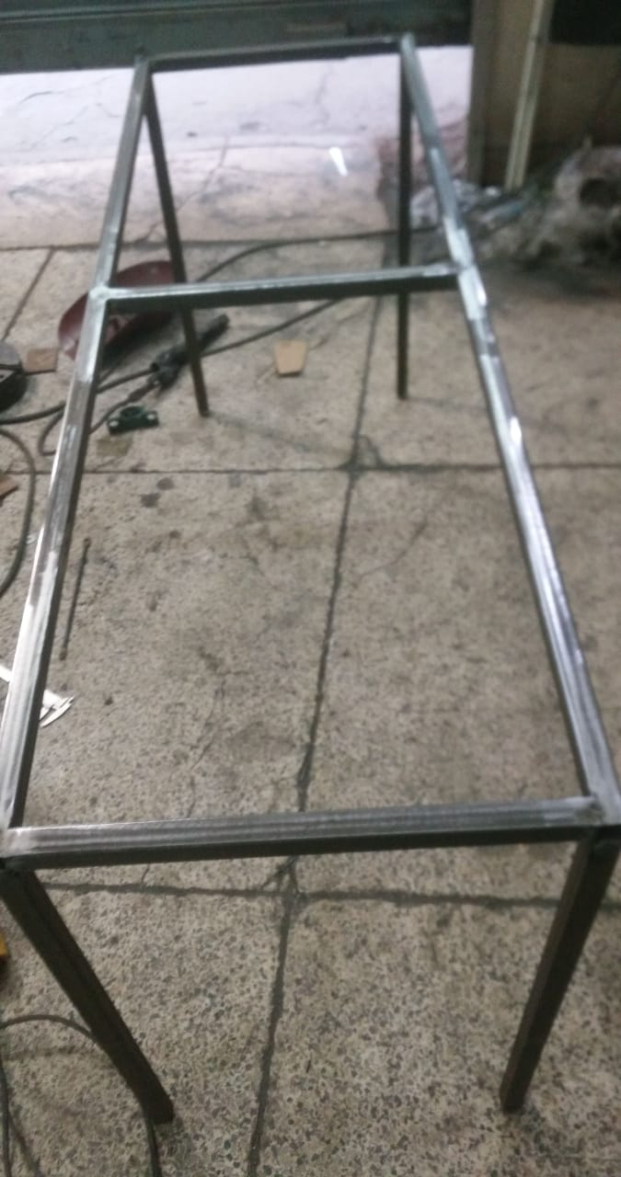 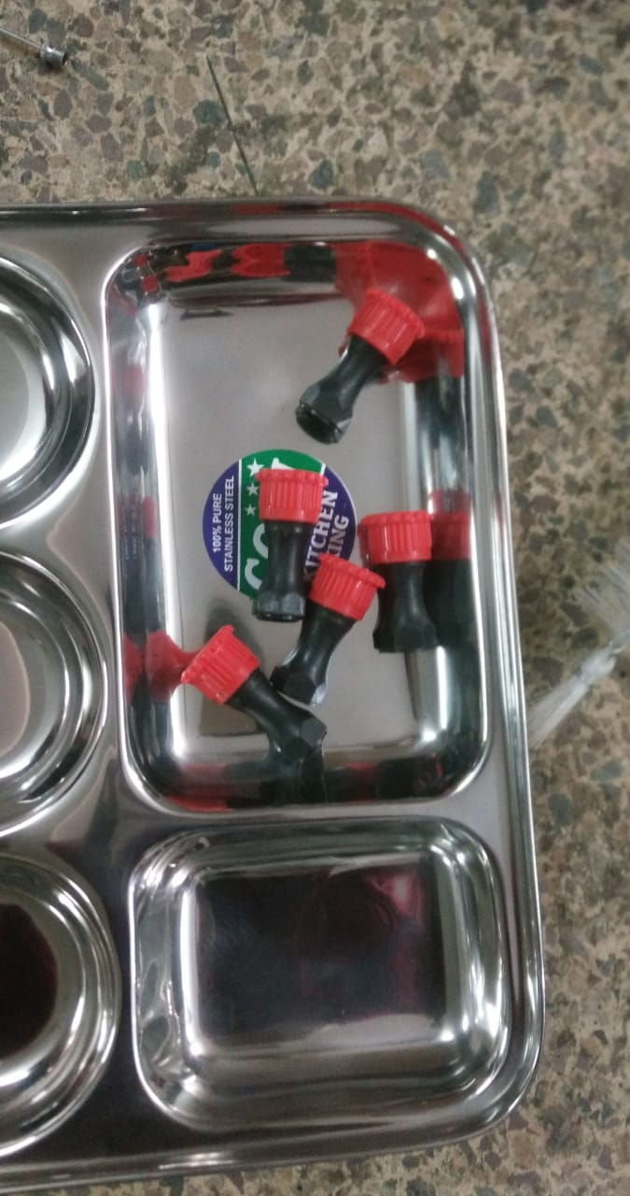

**Fig.5 - MILD STEEL FRAME** **Fig.6 - SPRAY NOZZLES**

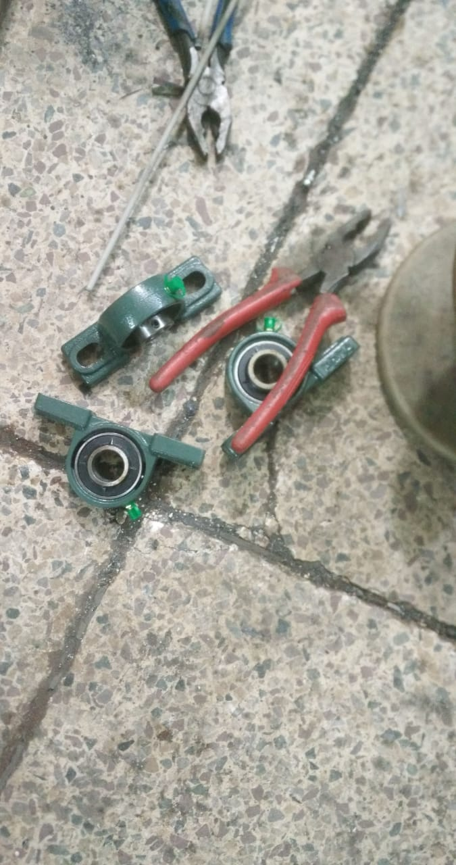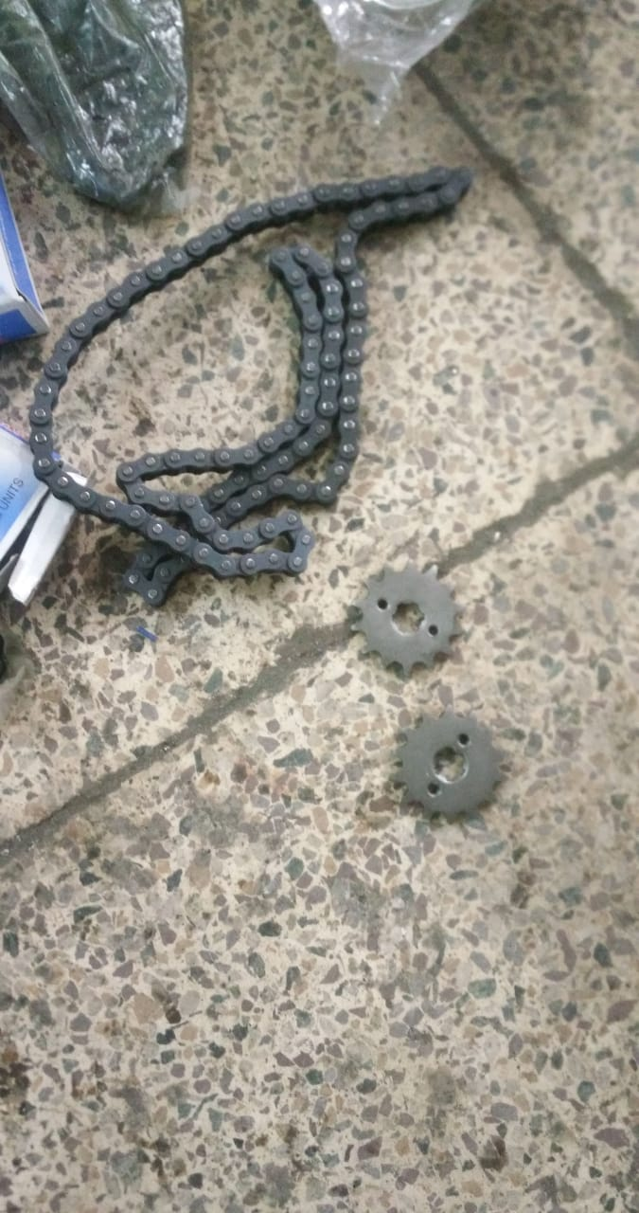

**Fig.7 - ROLLER BEARING Fig.8 - CHAIN AND SPROKET**

**9. DESIGN AND CALCULATIONS**

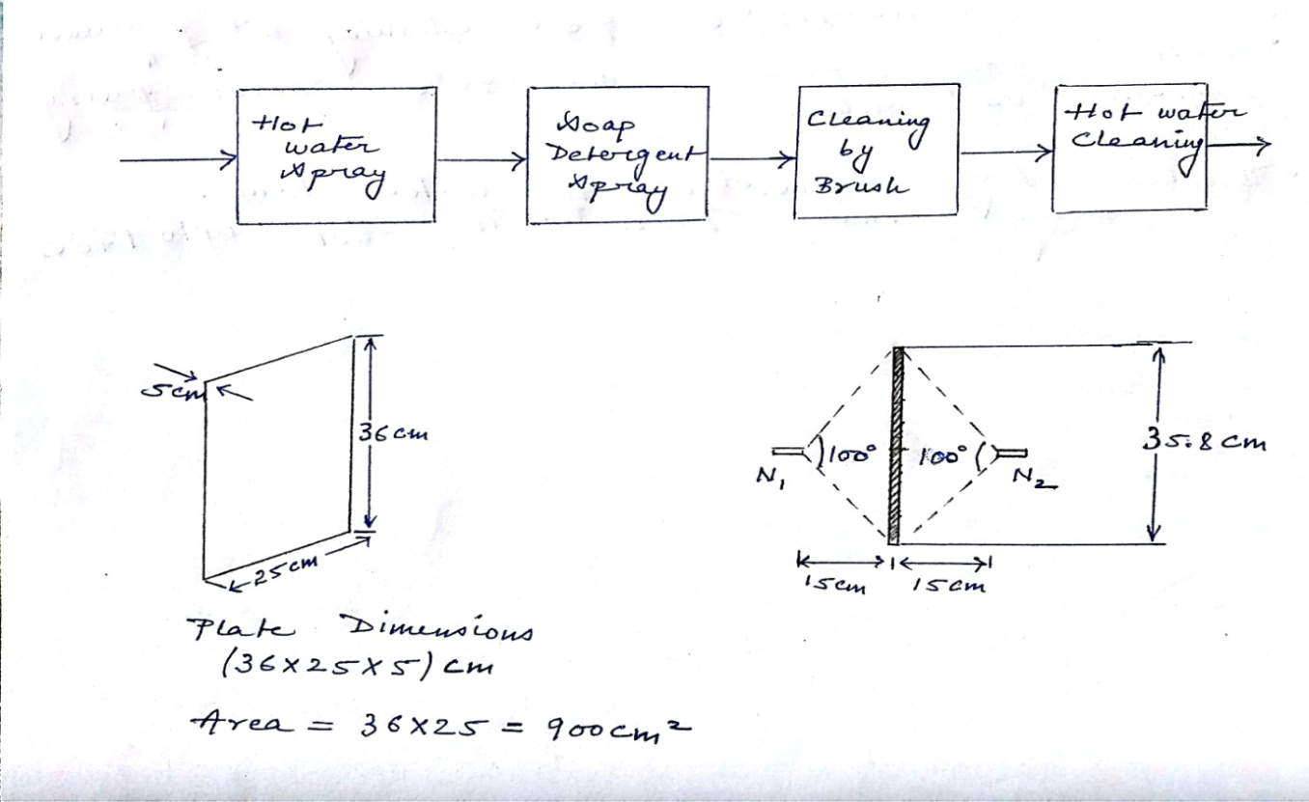

**Fig.9 - GENERAL LAYOUT**

The basic layout of automatic dishwasher consists of four stages. The first stage is the hot water spray to remove the oil and stains on the plate. Next the detergent added with a soapy water mixture which is ready to clean the dish. The brushes in the form of rollers are used which rotates continuously and cleans the incoming plate. In the last stage fresh water cleans the dishes for few seconds and they are now ready for drying.

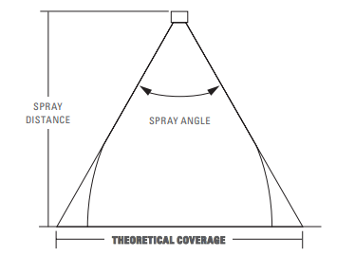

**Fig.10 - NOZZLE DESIGN (Spray angle and coverage)**

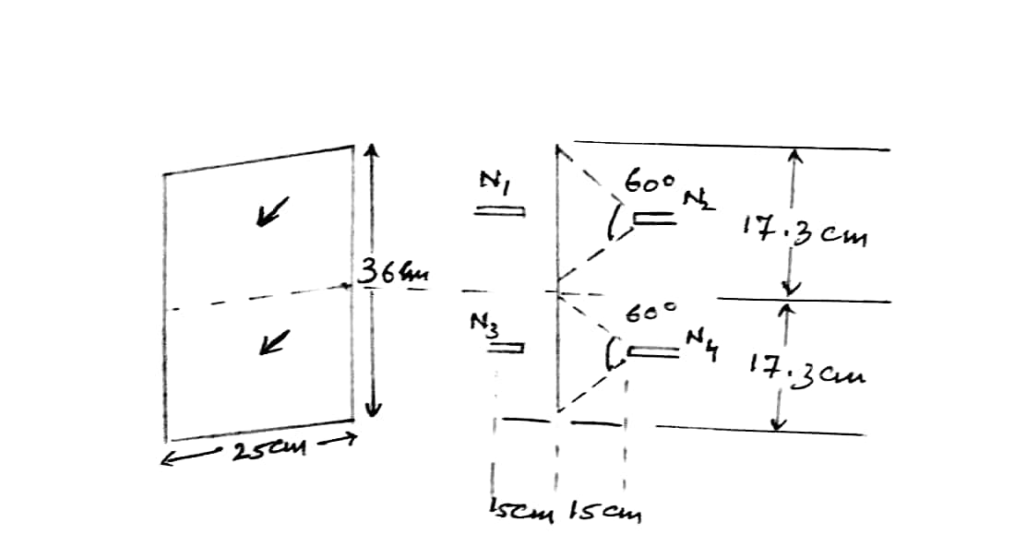

**Fig.11 - NOZZLE PLACEMENT**

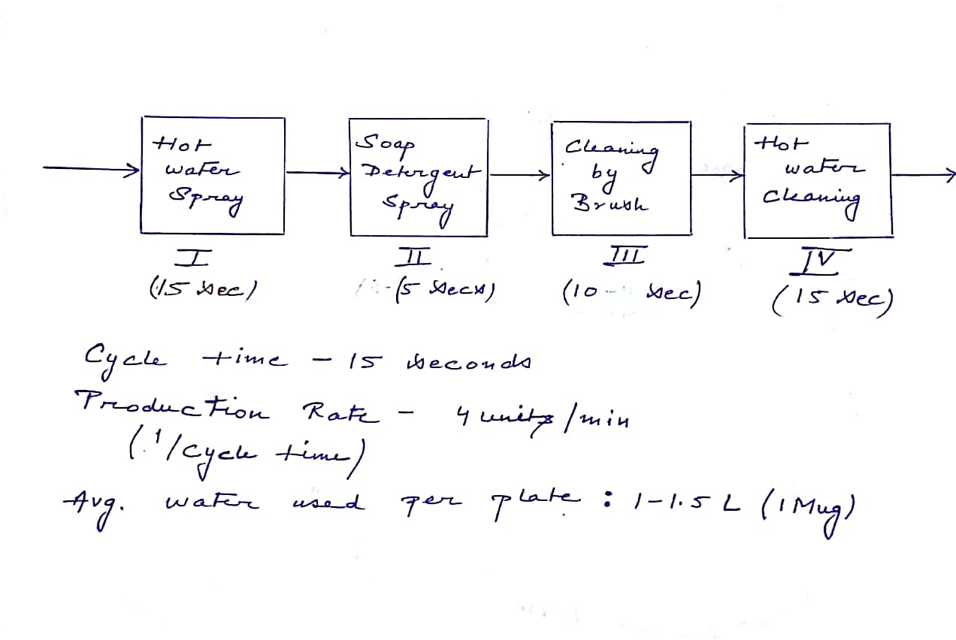

**Fig.12 - PROCESS RATE & CYCLE TIME**

* The cycle time of this dish washer as mentioned above is 15 seconds which means four plates are washed every minute. Also the average amount of water used per plate is 1-1.5 litre (1mug) which means 1.5L*4=6 litre of water is used per minute.
* Washing by a hand uses 2-5 gallons (7.5-10 litres) of water per minute.
* Household washing under running water uses (20-30 litres) of water in every 2 minutes. Assuming 6 plates are cleaned on an average in 2 minute time interval i.e.3.5-5 litre of water is used per plate.
* 600-750 ml of water is used in mess to clean one plate in unhygienic way.

**ACTUAL PROJECT**

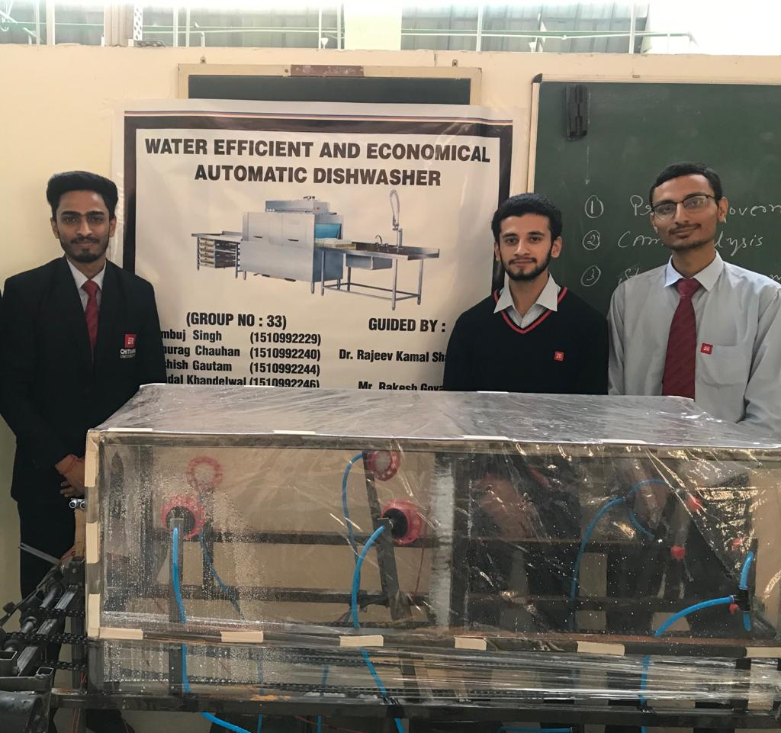**Fig.13 – FINAL WORKING PROJECT**

**10. PROGRAMMING FOR WHOLE CYCLE**

#include<REGX51.h>

#include<intrins.h>    // for using _nop_() function

#define data_port P0

sbit trig=P3^5;  // 15

sbit echo=P3^2; // 12

sbit rs=P2^7;

sbit rw=P2^6;

sbit en=P2^5;

sbit motor = P1^0;

sbit solenoid = P1^1;

sbit mainmotor = P2^0;

sbit sprin1 = P2^1;

sbit sprin2 = P2^2; // other motors will also be here

sbit sprin3 = P2^3;

sbit buzz   = P2^4;

void Delay(unsigned int);

void del();

void delay_ms(unsigned int msec)

{

int i,j;

for(i=0;i<msec;i++)

   for(j=0;j<1275;j++);

}

void lcd_cmd(unsigned char dat) // Function to send command to LCD

{

data_port = dat;

rs= 0;

rw=0;

en=1;

delay_ms(1);

en=0;

}

void lcd_data(unsigned char dat) // Function to send data to LCD

{

data_port = dat;

rs= 1;

rw=0;

en=1;

delay_ms(1);

en=0;

}

void lcd_string(unsigned char *str) // Function to send string to LCD

{

int i=0;

while(str[i]!='\0')

{

lcd_data(str[i]);

i++;

delay_ms(1);

}

}

void lcd_number(int val,unsigned int field_length) // Function to display number//

{

char str[5]={0,0,0,0,0};

int i=4,j=0;

while(val)

{

str[i]=val%10;

val=val/10;

i--;

}

if(field_length==-1)

while(str[j]==0) j++;

else

j=5-field_length;

if(val<0) lcd_data('-');

for(i=j;i<5;i++)

{

lcd_data(48+str[i]);

}

}

void send_pulse(void) //to generate 10 microseconds delay

{

TH0=0x00;

TL0=0x00;

trig=1;

_nop_();_nop_();_nop_();_nop_();_nop_(); //each _nop_() generates 1u sec of delay

_nop_();_nop_();_nop_();_nop_();_nop_();

trig=0;

}

unsigned int get_range(void)

{

int range=0;

int timerval;

send_pulse();

while(!INT0);

while(INT0);

timerval = TH0;

timerval = (timerval << 8) | TL0;

TH0=0xFF;

TL0=0xFF;

lcd_cmd(0xc0);

delay_ms(2);

lcd_string("Distance:");

lcd_cmd(0xc9);

if(timerval<35000)  //actually you need to use 38000 but the sensor may not work at higher levels

{

 range=timerval/59;

}

else

{

range = 0;

}

lcd_number(range,3);

lcd_string("cm");

if ( range <= 60 && range >= 0 )

{

buzz=0;

delay_ms(100);

buzz=1;

delay_ms(500);

mainmotor = 1;

sprin1=0;

delay_ms(800);

sprin1=1;

mainmotor = 0;

delay_ms(450);

sprin2 = 0;

delay_ms(800);

sprin2 = 1;

delay_ms(300);

sprin3 = 0;

delay_ms(950);

sprin3 = 1;

}

else

{

return range;

}

void main()

{

buzz=0;

delay_ms(50);

buzz=1;

delay_ms(50);

buzz=0;

delay_ms(50);

buzz=1;

delay_ms(50);

buzz=0;

delay_ms(50);

buzz=1;

delay_ms(50);

lcd_cmd(0x38);

lcd_cmd(0x0c);

  delay_ms(2);

lcd_cmd(0x01);

  delay_ms(2);

  lcd_cmd(0x80);

  delay_ms(2);

 lcd_string("Range finder");

 delay_ms(20);

TMOD=0x09;//timer0 in 16 bit mode with gate enable//

TR0=1;//timer run enabled//

TH0=0x00;

TL0=0x00;

echo = 1; //setting pin P3.2//

mainmotor = 0;

while(1)

{

get_range();

delay_ms(2);

}

}

void Delay(unsigned int del)

{

while(del++);

}

**11. ADVANTAGES**

* Very useful in reducing human effort.
* Washing dishes in a dishwasher is safer because there is less handling of the dishes than when you wash them in the sink.
* Dishwashers are more sanitary because they put the dishes through several cycles of scalding hot water, which disinfects them while cleaning. You can't put your hands in dish water that's as hot as the water used in a dishwasher -- typically 130 degrees Fahrenheit.
* More number of dishes can be washed in very short time.
* Better utilization of water.
* It is environmentally friendly. The amount of low-phosphate or phosphate-free dishwasher detergent is significantly less than liquid detergent used for an equal amount of dishes. A full dishwasher uses minimal electricity and water as compared to washing dishes by hand. For instance, you can save up to Rs 2500/- per year on your utility bill and save up to 5,000 gallons of water.

**12. LIMITATIONS**

* The filler basket needs regular cleaning to avoid rotten odor in the kitchen.
* A clogging in the drain pipe due to the left over foods or other materials will result in slow drain of the dishwasher.
* Another common failure of the dishwasher is caused due to the clogging in the holes of the dishwasher arms. The water is sprayed unevenly which results in poor washing.

**13. APPLICATIONS**

It can be used in large scale kitchens such as hotels, restaurants, langars etc., where large number of plates is required to be cleaned and at fast rate.

Since in such places cleanliness is often ignored at the cost of public hygiene often leading to infectious diseases such as malaria, dengue etc.

Thus, this concept of automatic water efficient dishwasher embeds control usage of water along with hygienic cleansing at minimum cost.

**14. PROJECT BUDGET**

|  |  |  |  |
| --- | --- | --- | --- |
| **COMPONENT** | **QUANTITY** | **COST PER UNIT**  **(in rupees)** | **TOTAL COST**  **(in rupees)** |
| **Cycle Chain(32 inch)** | 4 | 600 | 2400 |
| **Waste Tank (Acrylic Sheet)** | 1 | 1000 | 1000 |
| **12 V DC Motor (1.5 Watt)** | 2 | 250 | 500 |
| **12 V DC Motor (4.5 Watt)** | 1 | 1200 | 1200 |
| **Nozzles** | 6 | 40 | 240 |
| **Pump** | 3 | 400 | 1200 |
| **Battery (12V DC)** | 2 | 1000 | 2000 |
| **Gears** | 4 | 350 | 1400 |
| **Mild Steel Frame** | 1 | 1500 | 1500 |
| **Rubber Pipes** | 9 | 10 | 90 |
| **TOTAL COST** | | | **10,130** |

**15. CONCLUSION**

A dishwasher is not a luxury but a necessity which can make your life a lot easier. The best dishwasher should have a capacity suitable for your family's needs. It should also be easy to use, energy efficient and reasonably quiet. Moreover, the best dishwashers are the ones that can deliver spotless dishes without needing them to be manually rinsed beforehand. This design of automatic dishwasher can be used to wash eating utensils very cleanly and with the ease. As the motors selected can consume much less power so it will be the electrically better. Manual wash is usually done with cold water but hot water helps to kill harmful germs. And the utensils come out dry which means that there is no need for drying them which reduces human efforts to great extent .This is very much efficient in cleaning the dishes without human intervention. This saves lot of time and man power.

**FUTURE SCOPE**

Future work might be possible in the Following ways: to reduce the weight of the machine. To improve the speed of the cleaning process by using alternative motor. To develop new ways to save water and energy. To use the leftover water from prior rinse cycles to pre-rinse the next one. To use a sensor driven mechanism which automatically gives and cuts the supply of water to minimize wastage.

**Appendix 1**

Table 1-THEORETICAL SPRAY COVERAGE AT VARIOUS DISTANCES IN INCHES (CM) FROM NOZZLE ORIFICE

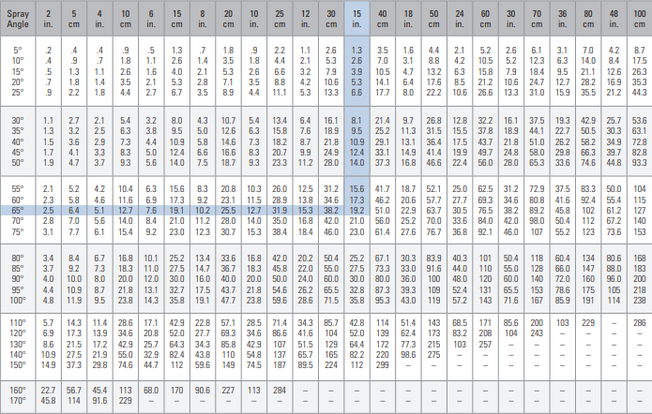

**REFERENCES**

1. Milocco, C., Electrolux Zanussi Elettrodomestici SpA, 1993. Method of controlling a washing cycle in an automatic dishwasher. U.S. Patent 5,264,043.

2. Cooper, Randall L., Mitchell N. Corbett, and Mark A. Cracraft. "Enhanced draining and drying cycles for an automatic dishwasher." U.S. Patent 5,806,541, issued September 15, 1998.

3. Geiger, Paul B. "Fill control for an automatic dishwasher." U.S. Patent 4,097,307, issued June 27, 1978.

4. Jaiswal, Pankaj H., Vaibhav V. Chitriv, Praful C. Panchabhai, Mohit H. Solanki, and Yogesh S. Date. "Review of Semi-Automatic Dish Washing Machine." (2017).